Roo Balance User Guide

Team 1
December 2, 2010

Team Members
Cuong Cu
Casey Droneburg
Kyle Emmons
David Haney

Contents

Contents 2
1 Introduction 3
2 Quick Start Guide 3
3 System Requirements 5
4 Main Scenarios of Use 5
5 Troubleshooting 6

Introduction
The Roo Balance application allows users a simple interface to access their Roo Bucks account information from a mobile device. This document will provide instructions for using the application to view balance, see recent transactions, and view merchant locations that accept Roo Bucks.

Quick Start Guide
- Tap the RooBucks icon in your device menu. The login screen will be brought up.
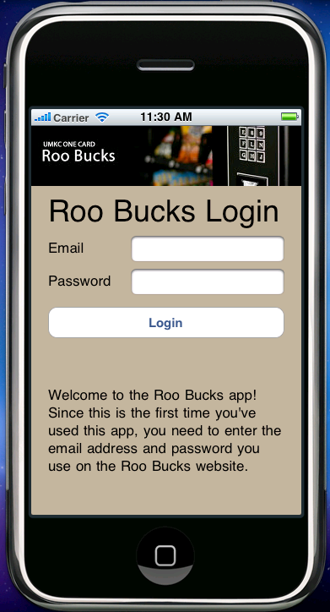
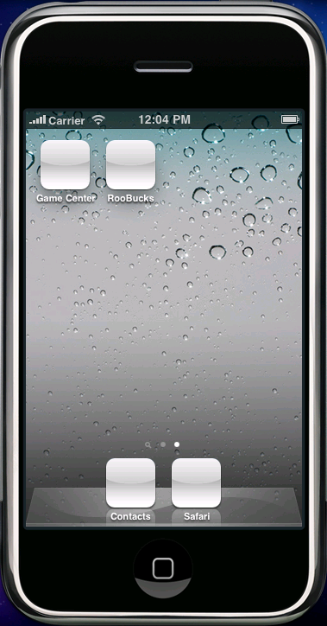

- Enter your E-Mail and Password.
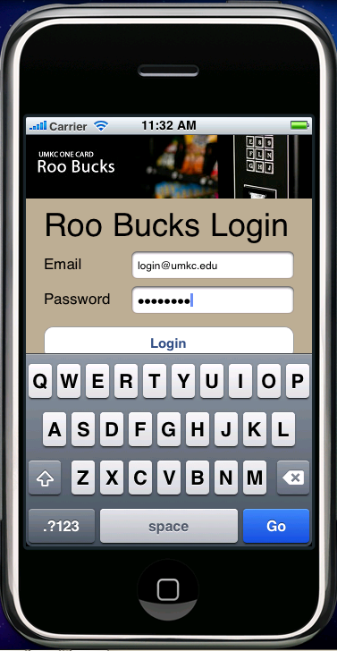
- Tap the Login button.
- Current Roo Bucks balance will be displayed.
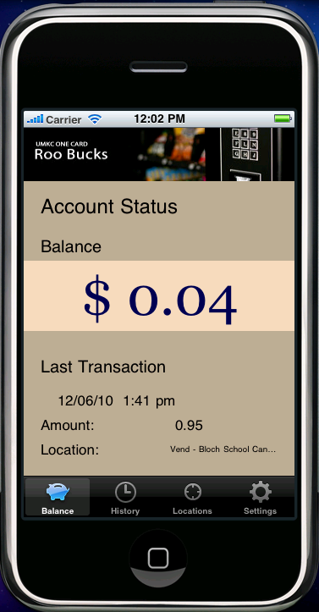

System Requirements
The Roo Bucks application should be installed on an iOS-compatible device. Refer to the System Documentation for instructions on installation.

Main Scenarios of Use

View Recent Transactions
- Tap the RooBucks icon in your device menu. The login screen will be brought up.
- Enter your E-Mail and Password.
- Tap the Login button.
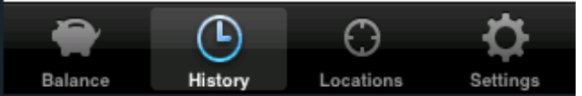
- Tap 'History' at the bottom on the screen.

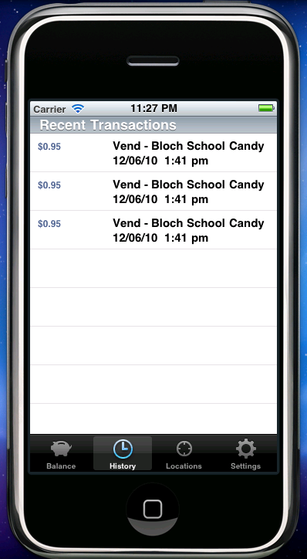
- Recent Roo Bucks purchases will be displayed.

View Merchant Locations
- Tap the RooBucks icon in your device menu. The login screen will be brought up.
- Enter your E-Mail and Password.
- Tap the Login button.
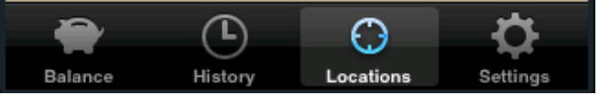
- Tap 'Locations' at the bottom on the screen.

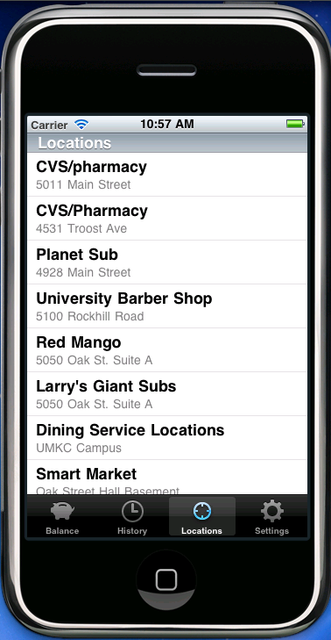
- Merchant locations accepting Roo Bucks will be displayed.

Troubleshooting

Missing or Incorrect Password or E-Mail
A message will be displayed in the event incorrect login information is entered. Try again with proper credentials to access the UMKC.ManageMyID.com website. If trouble is encountered, retrieve proper login information directly from the ManageMyID website.
